# https://upload.wikimedia.org/wikipedia/en/3/3b/Asia_Pacific_College_Logo.png

Asia Pacific College

#3 Humabon Place, Magallanes, Makati City

# SAO-DOCUMENT LIBRARY MANAGEMENT SYSTEM

Project Documentation Submitted

To the Faculty of School of

Computer Science and Information Technology

Of

Asia Pacific College

In Partial Fulfillment of the Requirements for the subject

Structured Systems Analysis and Design

By

Ferrer, John Kenneth H.

Jose, Chamber F.

Dulitin, Rempson P.

MI – 141

Mr. Manuel Sebastian Sanchez  
Professor

Table of Contents

SAO-DOCUMENT LIBRARY MANAGEMENT SYSTEM 1

Executive Summary 3

I. Introduction 4

1.1 Project Context 4

1.2 Purpose and Description 5

1.3 Objectives 5

1.4 Scope and Limitations 6

II. Review of Related Literature/Systems 6

III. Technical Background 7

IV. Methodology, Results and Discussion 9

4.1 Description of the Prototype, where applicable 9

V. Conclusions and Recommendations 11

VI. Appendices 12

# Executive Summary

The **SAO – Document Library Management System** is a system where all the organization in Asia Pacific College could comply to all the document requirements and propose a document. The client wants a system that would be able to collaborate to all the organization and track all the documents required for each organization. The system would allow the organization to read, update, and submit all the documents while the administrator will able to track all the process or changes on the documents and able to notify the organization to submit the documents needed for completion. Because of this system, they would able to work and comply to those document requirements. The objectives of this project is to track the document that is done by the organization and make it easier to the admin to update the requirements of the organization. The organization will able to submit a proposal anywhere he/she is. Because this system allows them to attach a document that will be process and every time he/she submit a document the administrator could see what is the status of that document. And with that we target to ease the work of the SAO and able to process the documents wherever they are. The transaction of each organization would be easily monitor and notify them by the administrator. All the functionality of our client is prioritize and know the user’s view because we believe that we should attain our client’s view for our system and make the user interface more effective to use.

# Introduction

## Project Context

The APC Student's Activities Office (SAO), in collaboration with different extra-curricular organizations in Asia Pacific College (APC), handle various transactions such as re/accreditation, financing, event handling and much more. because of the use of outdated technology and old school methods, transactions among SAO and the officers of extra-curricular organizations seemed to be inefficient concerning time management and lack of collaboration. Therefore, the developers of this project was assigned to integrate a website for a better documents management system that will bring improvements to the overall operation of the office

The existing process of transaction seemed to be cumbersome because of the large volume of papers used for document processing and some folders contained in their computer system to separate the documents per organization. We all know that this method can present some trouble for the office or even the organization, like human error and manual encoding of data.

With the development and integration of this SAO - Documents Library Management System, the office and the members of the organization itself are assured of a better and faster document transaction and thus, patronizing the integration of newer technologies to promote work ease, efficiency and versatility.

## Purpose and Description

SAO Documents Library Management System is developed to promote ease of transaction between the Student Activities Office (SAO) and all extra-curricular organizations in Asia Pacific College. This project aims to lessen the paper works for document processing and empower the collaboration among the members of the institution, specifically, the organization's officers and office directors.

## Objectives

General Objectives

* To develop collaboration between the Office Directors and Organizations' Representative/s
* To be able to promote the use of newer technology to lessen paper works and other workloads

Specific Objectives

* To provide the Student's Activities Office (SAO), a Document Library Management System, an efficient way to handle document transactions and event handling operations

## Scope and Limitations

The system will only be limited to two functions, firstly, it will serve as a document library that will store all files of different organizations of different types. Secondly, it will handle event handling operations where everyone can organize their appointments and/or hosted events.

In terms of user access, Only the Organizations' Representative, Adviser, Student Affair Head and the SAO Director have the access to the system. Moreover, these users will be grouped into two classifications, the Standard User and the Administrator. The standard user group will compose of the Organizations' Representative/s, Adviser, and the Student Affair Head. While on the other side, the Administrator will only be acted by only one person, the Student's Activities Office (SAO) Director. With regard to the user's privileges, the standard users are only permitted to upload and download files in the system where the said files are only limited to their Organizations' scope/point of view. Lastly, is to send event approval and set a new calendar / event invitation. On the other way around, the Administrator is accorded to create a new announcement, which can either be a Document Request or Calendar Invitation and Add a new organization where applicable.

# Review of Related Literature/Systems

* **Online Public Access Catalog (OPAC)**

is an online database of materials held by a library or group of libraries. Users search a library catalog principally to locate books and other material available at a library.

* **Enterprise Resource Planning (ERP)**

is business process management software that allows an organization to use a system of integrated applications to manage the business and automate many back office functions related to technology, services and human resources.

# Technical Background

The SAO Documents Library Management System will feature a document library manager to serve as a compiler of documents for each organization, a calendar for organizing events, which also features privacy settings, and a social media environment where stakeholders can collaborate with each other. focusing on its internal operation, the system will also handle real time synchronization with relation to document management of members of each organization and thus, eliminating repetitive workloads and saving more time. The system will involve the use of databases to act as record and file storage, some security implementations to ensure that all handled transactions are secured, web hosting server and/or applications for the website to be accessed anywhere which therefore promotes work feasibility, and web frameworks to expedite the development and integration of the system.

This project will be implementing the agile methodology which further promotes progressive system development. Moreover, this methodology, on our client's perspective, grants them the opportunity to suggest changes and their ideas that can contribute to the development and overall usability and/or performance of the system.

In addition, the system will be built using a framework named Cobalt. Cobalt Framework is a PHP Framework developed by one of the past APC student, Mr. JV Roig. The use of this framework can ease the development of the system for it features code generation, where developers are required to only have a fewer code tweaks. Also, it features some security implementations like protection to SQL Injection Attacks and Hijacking Sessions.

Focusing on the process within the system, with regard to document approval processing, the developers will implement some security measures which then involves the incorporation of Organizations' Adviser and Student Affairs Head as the actors/users in the system. This implementation will be used in lieu of the use of Electronic/Digital Signatures which is also prone to forgery.

The use of the system starts with the creation of organizations connected / related to the Student's Activities Office. Once all organizations have been created, to follow will be the registration and designation of a representative for each organization which will then be responsible in administering his/her organization's requirements, etc.

SAO Documents Library Management System, in a general context, will serve as a Document & Event Handling Transaction collaboration platform among the Organizations' Representative, Advisers, Student Affair Head and lastly, the SAO Director. Wherein, the SAO Director is responsible of starting a new transaction through sending / posting announcements which is most of the time, document related requirements or sometimes, event handling.

Although Student's Activities Office is involved / part of APC Community/Premises, the system will not be incorporated with the APC's Flavio or any other website hosted by the institution. Instead, the system will standalone and will be deployed into another web server but will still be part of the institution's property.

# Methodology, Results and Discussion

## Description of the Prototype, where applicable

This section describes how the Student Activities Management System works across different organizations and actors in the system and how the system works to enable collaboration among them. The operation starts when the Administrator (SAO Head) has entered / logged in the system. As what is being stated in the Technical Background, the SAO head has the privilege to perform CRUD operations on documents, document requests, calendar events, document requirements, organizations, representatives, and many more.

By the time the Student Activities Office Head has created a new document request, the information entered in the system will be sent to the database. Migrating on the standard user's view, once the database has received the details entered by the admin, the read status of a particular announcement will be given a value of 0 or any value that might correspond to a negation. All records with a false value will be shown as a notification in the user's account page.

The database design for this system, in terms of document and requests has established a connection that a document request may correspond to one or more document submissions. In relation to this, it is assumed that for every document request received by each organization representative, there will always be a series of distinctive requirements to be expected by the user and file submissions for SAO head.

Dealing with the document approval processing, the system will be using the Pretty Good Privacy (PGP) protocol wherein, the user will be using a public key to upload and encrypt the document, while the adviser, student affair head and the SAO head will be using their private key to decrypt, access and sign documents. When the user has uploaded a file document submission on the system, the submission and new document notification will be first accessed by the adviser. The adviser will decrypt the uploaded document using his/her private key, after signing the document, the adviser will be sending the document to the student affair head to perform the same procedure and lastly, to the student activities office head. after the process, the document may be marked as approved or discarded if not approved; which means to say that the document will be deleted in the system.

# Conclusions and Recommendations

The use of old document processing methods, as what is being exemplified by the Student Activities Office (SAO) seemed to be cumbersome for it can produce / trigger different kinds of problems like human error, lost documents and many more.

In the advancement of technology, though some companies still adopt the old method of performing their tasks, those methods could not anymore support the way the office handle its operation because of growing demand coming from different organizations. As the Student Activities Management System is about to be implemented, the Student Activities Office and Organization Representatives are assured of better document and event handling experience because this system incorporates the different transactions being performed from in and outside the office.

# Appendices

Event Tables

* Backend

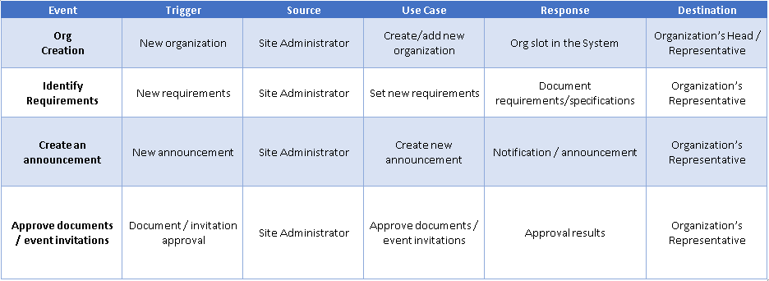

* Frontend

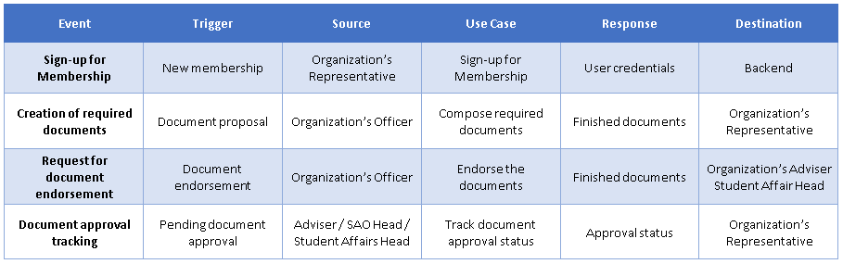

Use Case Full Description

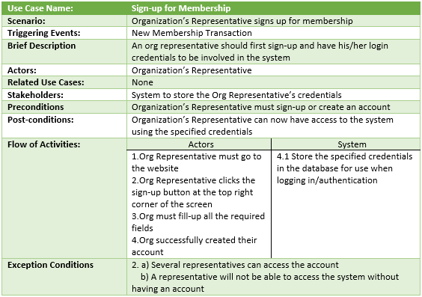

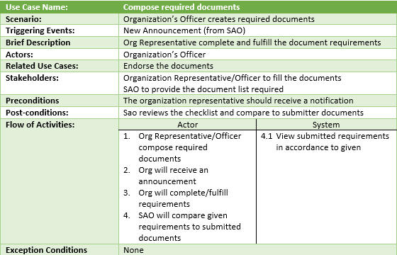

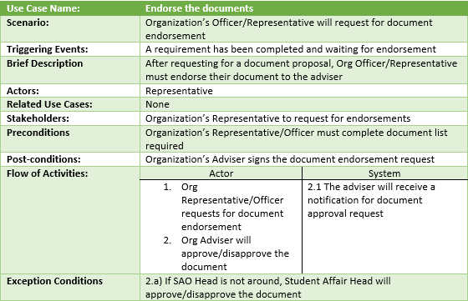

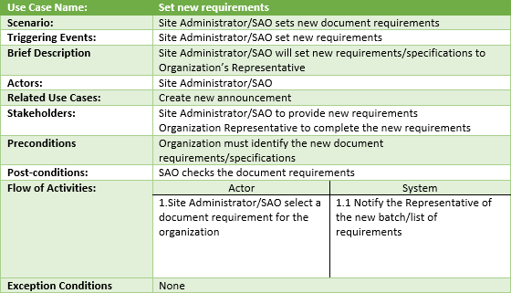

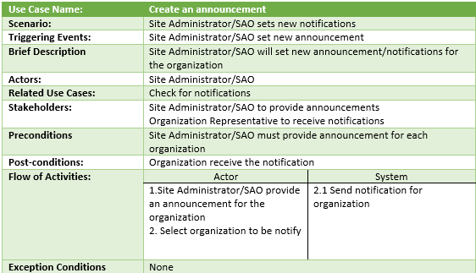

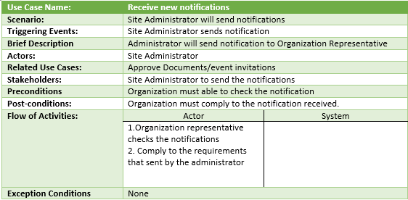

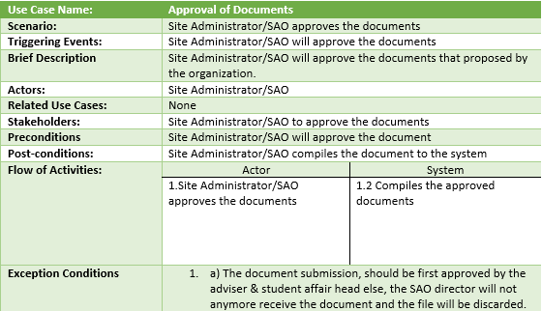

Context Flow Diagram

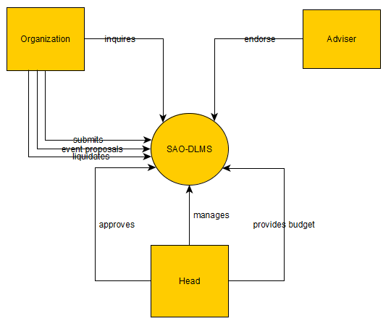

Data Flow Diagram

* Level 0

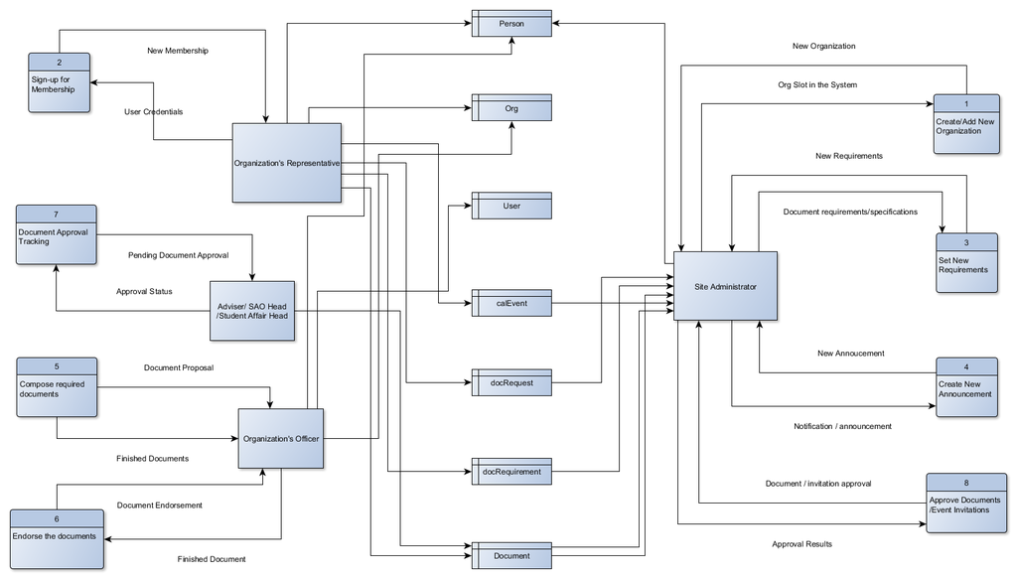

Entity Relationship Diagram

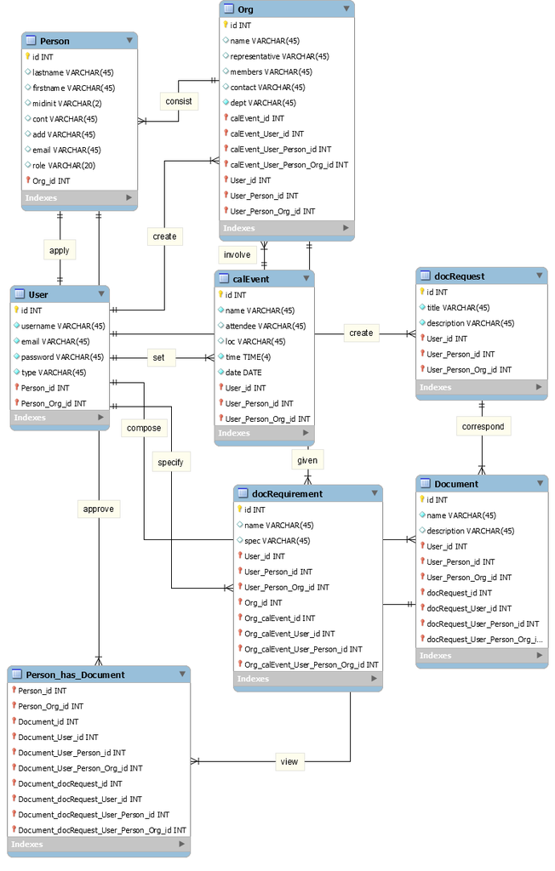

Use Case Diagram

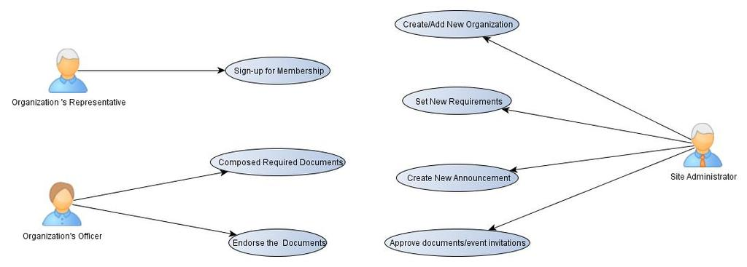

UML Diagrams

* Communication Diagram

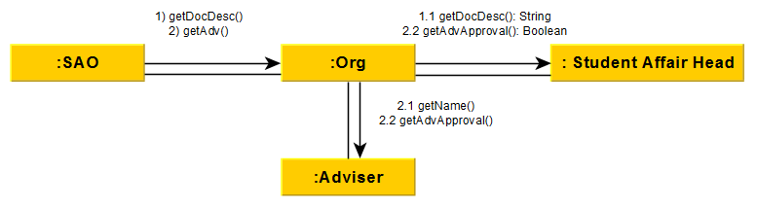

* Object Diagram

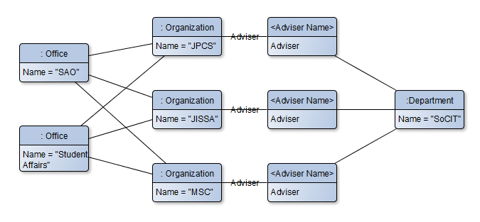

* State Machine Diagram

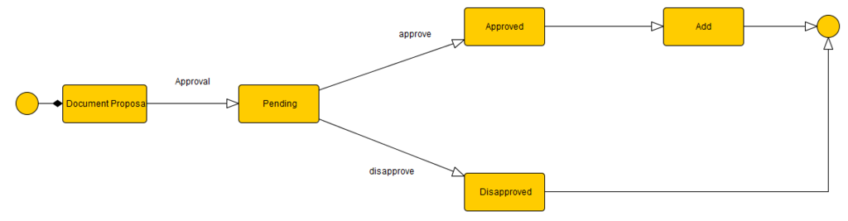

* Timing Diagram
* Organization

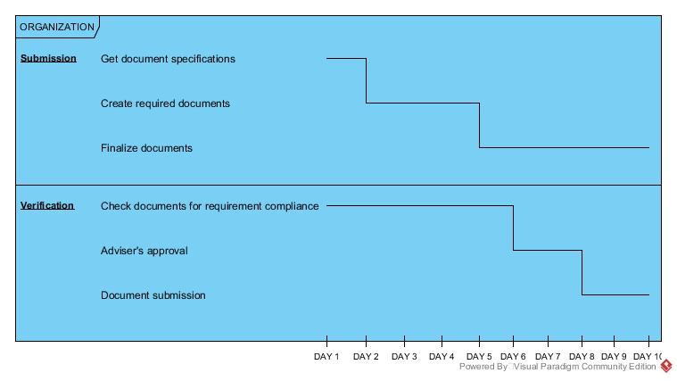

* Adviser & Student Affair Head

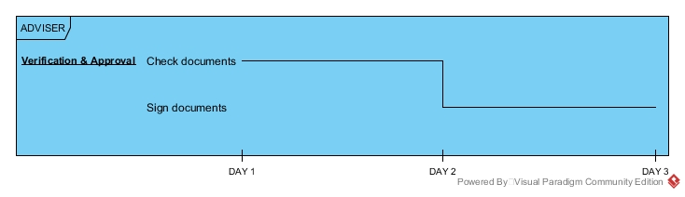

* Student Activities Office Head

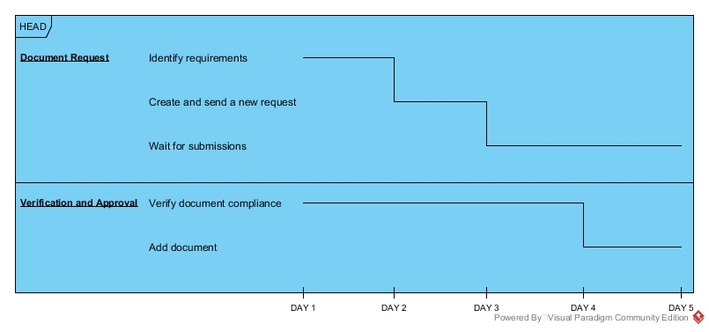

* Class Diagram

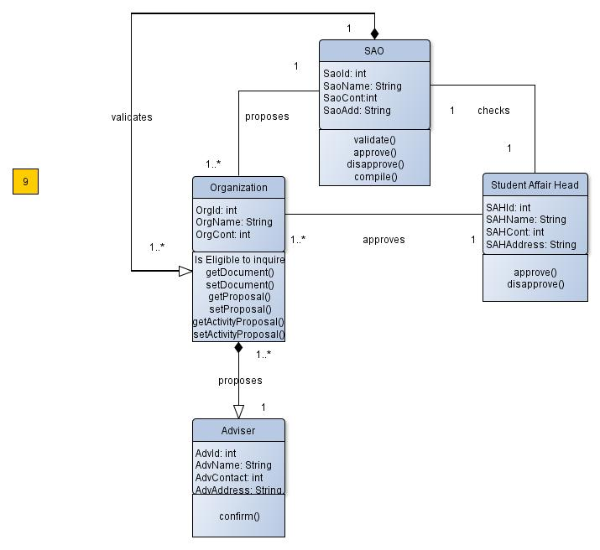

* Sequence Diagram

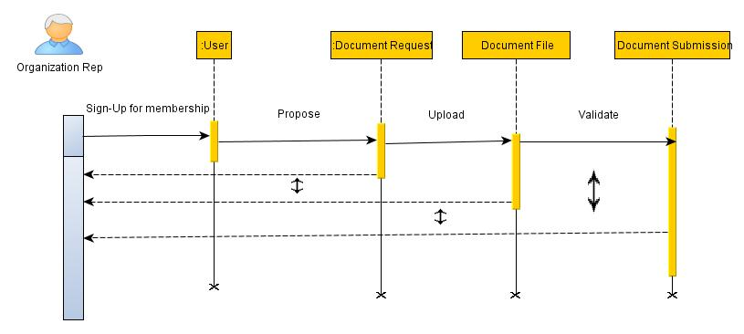

* Package Diagram

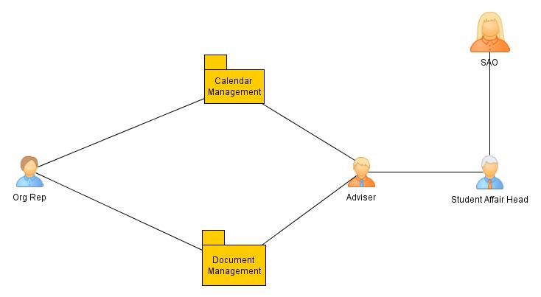

* Deployment Diagram

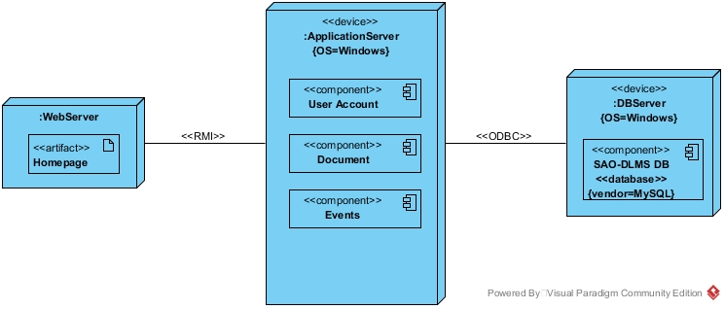

* Activity Diagram
* Backend

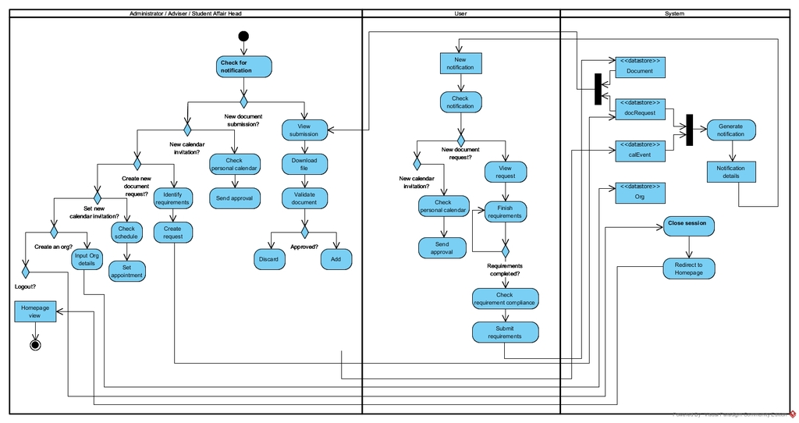

* Frontend

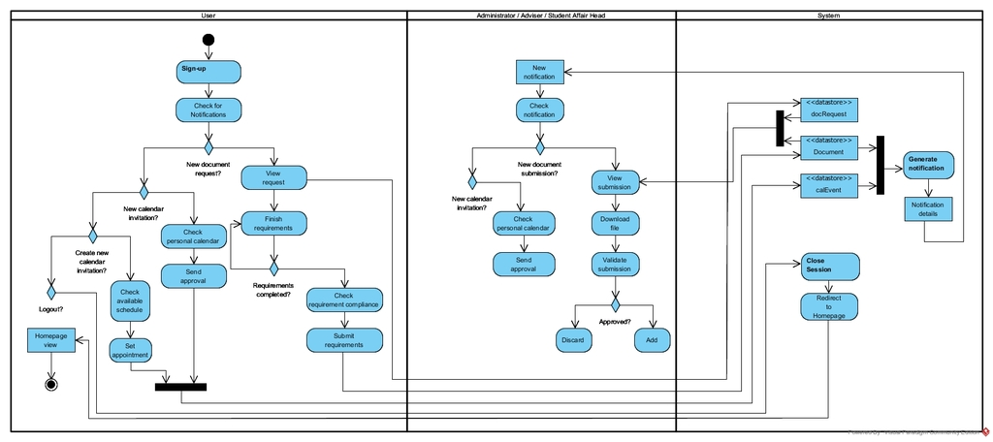

* Component Diagram

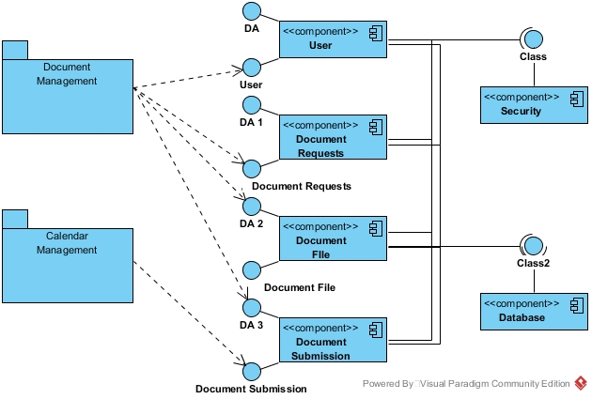

* Composite Structure Diagram

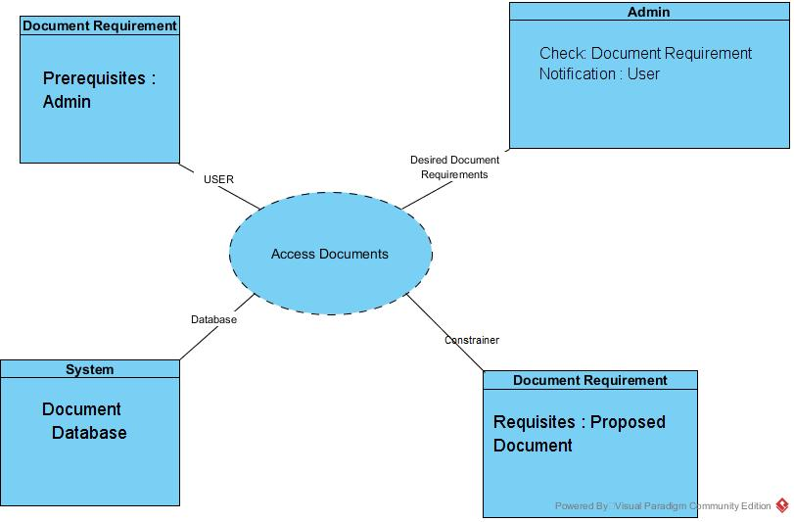

* Interaction Overview Diagram

